MSE 310: Introduction to Electro-Mechanical Sensors and Actuators

Project Report

July 6, 2015

Group 29

Daniel Kitt : 301139645 ______________________
(Gene) Jun Li: 301152342 ______________________
Refayet Siam: 301210102 ______________________
Ferry Tanjaya: 301215346 ______________________

Prepared for:
Dr. Edward Park

SCHOOL OF MECHATRONIC SYSTEMS ENGINEERING
SIMON FRASER UNIVERSITY

Table of Contents
Table of Figures ii
1. Introduction 1
2. System Overview 1
3. Algorithms 6
4. Flow Chart Error! Bookmark not defined.
5. Summary 8
6. Conclusion 8
References 8

Table of Figures
Figure 1. Chain conveyor 1
Figure 2. Sorting Area 2
Figure 3. The Assembly Chute 3
Figure 4. Belt Conveyor 4
Figure 5. Sensing station 4
Figure 6. Reject Area 5

Introduction

In this project we are using ICT3 system to represent a typical industrial automation system. ICT3 using a suitable interface card or a PLC of 24v D connectors to be able to connect the system to computer. An ICT3 system includes the component sorting, assembly, inspection and accept/reject process. To simulate an industrial process, the ICT3 has been designed to use a range of industrial sensor which is directly connected to the PLC inputs. The system has been designed to realistically represent component sorting, inspection and assembly process that can be controlled from a computer.

System Overview
The ICT3 system consists chain and belt conveyor, variety of industrial sensors and actuator that represent the industrial automation system.

- Chain Conveyor
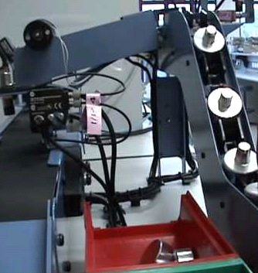

Figure 1. Chain conveyor

Chain conveyor is the conveyor that transports the assembly up for the inspection. The purpose of using chain conveyor is to put some distance between every assembly in order for the sensor to read more accurately.
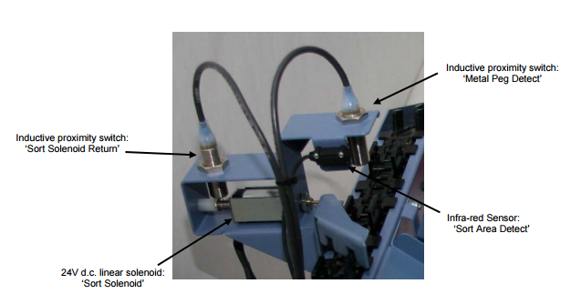
- Sorting Area
Figure 2. Sorting Area

Sorting Area consists of several sensors that will inspect the operation.
- The Metal peg detector will detect the metal peg; the inductive proximity switch will turn on if it does detect through metal.
- Sort Area Detect, it will detect metal peg or plastic peg that are under Infra-red sensor. The light indicator will change from green to red if plastic peg or metal peg is below this sensor.
- Sort Solenoid, it is a 24V d.c linear solenoid that will eject only the plastic peg to the next operations. It will return to original position after ejected.
- Sort Solenoid Return, which will turn on when Sort Solenoid at the original position.

In this process, the chain conveyor will carry up the metal peg and plastic peg for inspection. If it is metal peg, it will let it pass through for the next operations, and if it is plastic peg, the Sort Solenoid will eject it to gate.

- The Assembly Chute

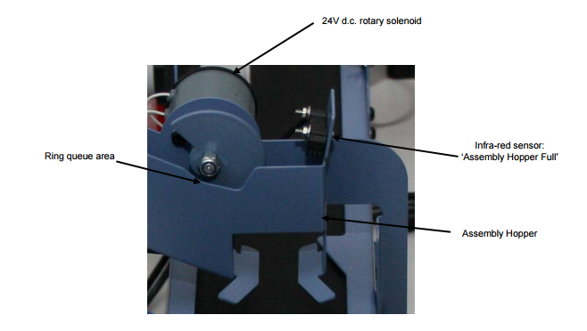
Figure 3. The Assembly Chute

After the plastic peg ejected, it will go to the next operation.
- Ring queue area, this is the place when for the plastic peg to queue for the metal peg. The ring queue area can only hold for 5 rings, and when the area is full, the ring will pass through the Sorting Area and will be counted as faulty components.
- Assembly Hopper, this is the place for the ring to wait for pick up by the metal peg.
- Assembly Hopper Full, it will detect the ring that stays Assembly Hopper. The infra-red sensor’s indicator will change from green to light if there is a ring stays in Assembly Hopper.
- 24V d.c rotary solenoid, this is the gate that let through the Assembly Hopper when there is no ring inside there.

In this process, the ring will be slide through to Assembly hopper to wait for the metal to pick up.

- Belt conveyor
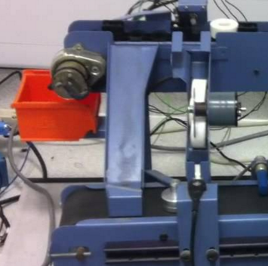

Figure 4. Belt Conveyor

After the metal pass through the Sorting Area, the metal peg will slide down and the belt conveyor will carry the metal for the next operations.

- The Sensing Station
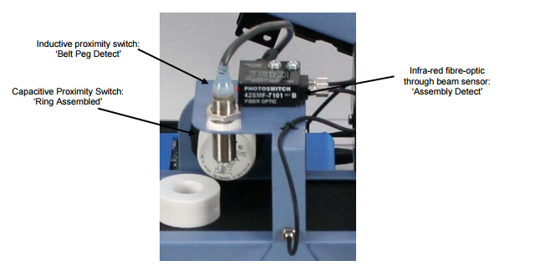
Figure 5. Sensing station
The assembled components continue along the belt conveyor where it passes through Sensing Station.
- Belt Peg Detect, which will detect the presence of metal peg. The inductive proximity switch will turn on if there is presence of metal.
- Ring Assembled, which will detect the present of assembled ring. The capacitive proximity switch will turn on if there is presence of assembled ring.
- Assembly detect, which will detect any component that pass through it. The infra-red fibre-optic through beam sensor’s light indicator will change from green to red if any component pass through it

The component’s data that pass through sensing station will be recorded and the accepting/rejection will be done when it reaches the Reject Area

- The Reject Area
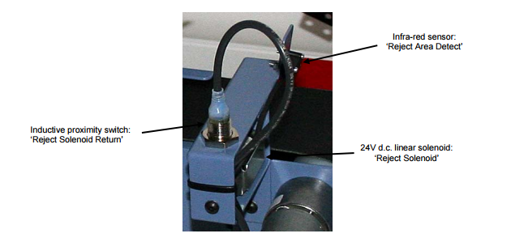
Figure 6. Reject Area

At this section, selection is being made.
- Reject Area Detect, which will detect components below the infra-red sensor. The infra-red sensor’s light indicator will change from green to red if any components below this sensor
- Sort Solenoid, it is a 24V d.c linear solenoid that will eject uncomplete assembly. It will return to original position after ejected.
- Sort Solenoid Return, which will turn on when Sort Solenoid at the original position.

Algorithms

Flow Chart
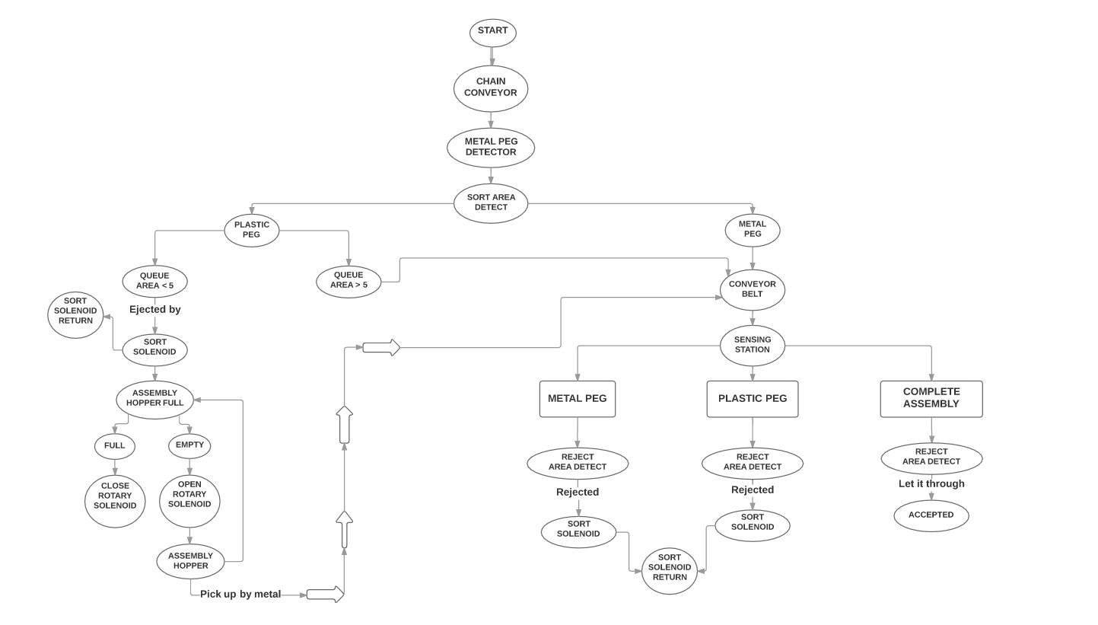

Summary

Conclusion

References

[1] | S. Arzanpour, Lab 1, Surrey: SFU, 2015.
[2] | F. Golnaraghi and B. C. Kuo, Automatic Control Systems 9th Edition, New Jersey : John Wiley & Sons Inc., 2010.

